

**Phonics Intent, Implementation and Impact Statement**

**Intent**

At Sandwich Infant School, we believe that all our children can become fluent readers and writers. This is why we teach reading through *Little Wandle Letters and Sounds Revised*, which is a systematic and synthetic phonics programme. We start teaching phonics in Nursery/Reception and follow the [*Little Wandle Letters and Sounds Revised* progression](https://www.littlewandlelettersandsounds.org.uk/wp-content/uploads/2021/06/Programme-Overview_Reception-and-Year-1.pdf), which ensures children build on their growing knowledge of the alphabetic code, mastering phonics to read and spell as they move through school.

As a result, all our children are able to tackle any unfamiliar words as they read. At Sandwich Infant School, we also model the application of the alphabetic code through phonics in shared reading and writing, both inside and outside of the phonics lesson and across the curriculum. We have a strong focus on language development for our children because we know that speaking and listening are crucial skills for reading and writing in all subjects.

**Implementation:**

In reception and Y1, children follow the synthetic phonics programme Little Wandle Letters and Sounds Revised. Phonics is taught daily and children have the opportunity to review and revisit regularly. Letter sounds are taught using pure phonics, blending sounds, segmenting words and learning tricky words for reading and spelling. A consistent approach is adopted throughout the school.

Phonics starts in reception from week…., as soon as the children are all in. This is to ensure the children make a strong start.

By the end of reception, children will have been taught up to the end of phase 4, and they will be able to confidently read words and sentences containing all graphemes and high frequency words taught.

Reception lessons start at 10 minutes, with daily additional oral blending – increasing to 30 minutes as soon as possible.

By the end of year 1, children will have been taught up to the end of phase 5.

Y1 lessons are 30 minutes long.

Where our children are at risk of falling behind, they will be given additional catch up sessions, in addition to their daily phonic lessons.

By the time children reach Y2, we’d hope that all children are secure in all phonic knowledge taught. We understand that for some children, they may require further catch-up support. Where this is the case, children will continue with additional catch up lessons to address specific phonic, blending and reading skills. These are short, sharp sessions that will last 10 minutes in length, at least three times a week.

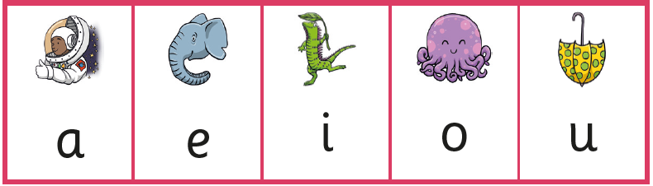

**Impact**:

A whole class approach to phonics is used within our school, however

assessment is used to monitor progress and to identify any child needing additional support as soon as they need it.

Assessment for learning is used:

* daily within class to identify children needing Keep-up support
* weekly in the Review lesson to assess gaps, address these immediately and secure fluency of GPCs, words and spellings.

Summative assessment is used:

* every six weeks to assess progress, to identify gaps in learning that need to be addressed, to identify any children needing additional support and to plan the Keep-up support that they need.
* by SLT and scrutinised through the Little Wandle Letters and Sounds Revised assessment tracker, to narrow attainment gaps between different groups of children and so that any additional support for teachers can be put into place.

Statutory assessment

* Children in Year 1 sit the Phonics Screening Check. Any child not passing the check re-sits it in Year 2.

Ongoing assessment for catch-up

* Children in Year 2 are assessed through their teacher’s ongoing formative assessment as well as through the half-termly Little Wandle Letters and Sounds Revised summative assessments.

**Support for Parents**

Phase 2 – Reception Autumn 1 graphemes. <https://www.littlewandlelettersandsounds.org.uk/resources/for-parents/>

Phase 2 – Reception Autumn 2 graphemes.

<https://www.littlewandlelettersandsounds.org.uk/resources/for-parents/>

Phase 3 – Reception Spring 1 graphemes.

<https://www.littlewandlelettersandsounds.org.uk/resources/for-parents/>

A guide to alien words

<https://www.littlewandlelettersandsounds.org.uk/resources/for-parents/>

How we teach tricky words

<https://www.littlewandlelettersandsounds.org.uk/resources/for-parents/>

How we teach blending

<https://www.littlewandlelettersandsounds.org.uk/resources/for-parents/>